***ESTIMATION OF HEAT TRANSFER IN RADIATOR WITH DIFFERENT NANO FLUIDS USING CFD***

***Harshit Varshney, Harshit Pachauri, Nihar Agrawal, Prince Saini***

***Department of Mechanical Engineering, Zakir Hussain College of Engineering and Technology, Aligarh Muslim University, Aligarh-202001, U.P., India***

***ABSTRACT***

*The goal of this research is to improve radiator performance by increasing heat transfer rates in an engine cooling system using nano fluids. A radiator is a device that removes excess heat from an engine cylinder so that it can function at its intended temperature. Researchers have recently concentrated on better heat removal approaches, such as using water or water + nano-fluids as radiator coolants. A nanofluid is a fluid made up of colloidal nanoparticle suspensions in a base fluid. The thermal properties of nanofluids are far superior to those of ordinary fluids. These fluids have nanometer-sized particles in them. The simulation study was carried out to estimate the variation in thermal conductivity and heat transfer rate of the selected nanofluids, and the findings were compared at the conclusion with the base fluid.*

***INTRODUCTION***

*As the demand of modern technology for device performance and device miniaturization is increasing, there is a need to develop new types of coolant that are more efficient in terms of heat transfer. Most commonly used coolants in radiator are water and ethylene glycol, but their thermal conductivity is very low. In the current world, we require more and more powerful water-cooled engines in modern cars and tractors. But it created problems of insufficient rate of engine cooling. Due to this, we require a compact design of a radiator which has small in size and has the equivalent capacity of engine cooling.* *So, there is a need to look at something new technology that has a large potential of heat transfer enhancement. It is seen that nano-fluid is a potential candidate for the automobile sector and in the field of agriculture such as tractors where we need to cool engine very fast for continuous use. The development of nano-sized particles helped in increasing the heat transfer performance.*

***NANOFLUIDS-***

*The concept of nanofluids was first discussed by choi (USA) in 1990’s. Nanofluid is a dilute liquid suspension of particles with at least one critical dimension smaller than ~ 100 nm. Nanofluid is a class of solid-liquid composite materials consisting of solid nanoparticles dispersed in a heat transfer fluid. Heat transfer performance of base fluid can be enhanced by adding high thermal conductivity nanoparticles.*

**Advantages and Disadvantages of Nano-Fluid**

|  |  |
| --- | --- |
| *ADVANTAGES* | *DISADVANTAGES* |
| Higher thermal conductivity results in a higher heat transfer coefficient, which is mostly due to laminar flow. | Because of the lower pressure, it needs to increase the pumping power. |
| Because of the enhanced heat transfer, smaller devices can be made available. | The high expense of nanoparticle suspension, particularly ones that require the addition of chemicals like surfactants to promote stability. |
| Higher dispersion stability when particles move in a Brownian motion. | When a fluid is in a state of stagnation for a long time, particles accumulate and the flow paths close. |
| Variable particle concentrations adjust attributes like as heat conductivity and surface wettability to suit diverse applications. | Corrosion of subsided parts caused by flow |

*Various types of nanomaterials are classified as-*

***NANOMATERIALS***

***CERAMIC METALLIC ALLOY CARBONBASED***

*Al2O3, CuO, TiO2 Ag, Au, Cu, Fe, Ag-Cu , Ag-Al, DIAMOND,*

*SiC, FeO Ni Al-Cu GRAPHITE*

*Degree of performance of nanofluids mainly depend upon* ***nanoparticle concentration, base fluid, particle size*** *and* ***particle morphology.***

*Some common nano fluids are tiO2- water, Al2O3-blend with water and when we vary concentration of nano fluids it also affects heat transfer rate that we can have lower heat transfer rate in starting stage i.e. when operating at low rpm and higher at latter stage i.e. at high rpm. Nano fluids can also we used in lubrication process****.***

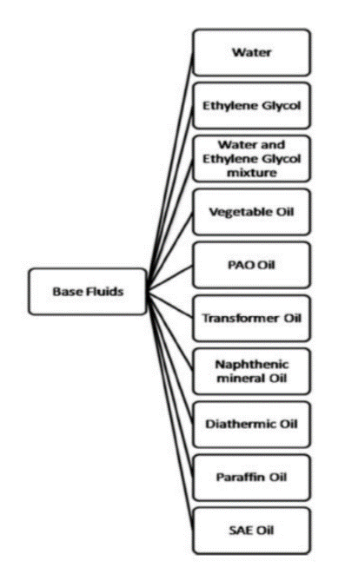*The present Aim is the heat transfer enhancement in car radiators by using various types of nano fluid-like Al2O3, MgO, SiO2, TiO2, etc. using the automobile and tractor industries.*

**Conventional Fluids used in Nano Fluids**

***LITERATURE SURVEY***

*Sadik Kakac, et al, in his literature survey showed that nano-fluids significantly improve the heat transfer capability of conventional heat transfer fluids such as oil or water by suspending nanoparticles in these base liquids. The understanding of the fundamentals of heat transfer and wall friction is prime importance for developing nano-fluids for a wide range of heat transfer application.*

*Devireddy Sandhya, et al., studied that the performance of ethylene glycol and water based TiO2 nano fluids as an automobile radiator coolant is determined experimentally. Nanofluids were prepared taking 40% ethylene glycol and 60% water with volume concentrations of 0.1%, 0.3% and 0.5% of TiO2 nano powder. Experiments were conducted in the range of Reynolds numbers from 4000 to 15,000. At the concentration of 0.5% enhancement in heat transfer rate up to 37% with respect to base fluid. The variation of fluid inlet temperature to the radiator (in the range tested) slightly influences the heat transfer performance. Brownian motion of nanoparticles may be one of the major factors in the enhancement of heat transfers.*

*Siraj ali ahmed et al, concluded from his work, by using TiO2 nanofluid as a coolant in engine radiator he observed that the overall efficiency of the engine is increased. And also due to the presence of TiO2 particles in the nanofluids heat transfer coefficient is significantly increased by 0.2% nanoparticle concentration by checking with pure water.*

*Saxena et al. (2018) focused on the experimental and numerical studies carried out by previous researchers on metallic/non-metallic oxide nano coolant, which are segregated with different nano coolant as CuO, Al2O3, TiO2, and SiO2. The review focuses on suitable volumetric concentration, sizes of nano particles used by researchers and applications for analysis. This review will be useful for researchers and scholars working in the field of applications of nano technology for enhancement of heat transfer fluids. However, lots of researcher work is still needed in the field of preparation and stability, characterization and applications to overcome the challenges.*

*Micali et al. (2018) experimental campaign has been carried out on a 4-strokes single cylinder engine, aimed to assess whether the use of nano fluids, instead of water, could be a valuable solution to reduce peak engine temperature. Such nano fluids were characterized by higher thermal conductivity compared to conventional fluids, due to CuO nano particles added at different concentrations within the base fluid.Boopathi et al. (2018) firstly preparation of novel composite fly ash nano fluid was made for 0.2- 2.0% volume concentration of fly ash particles and mass density, thermal conductivity, specific heat, dynamic viscosity of fly ash nano fluid were measured using standard methods and compared with thermo-physical properties of Alumina (Al2O3), Copper Oxide (CuO), Ferrous Oxide (Fe2O3), Silicon Oxide (SiO2), Titanium Oxide (TiO2).*

***PROBLEM DESCRIPTION***

*From newton’s law of cooling, we know that convective heat transfer Q = hAΔT as we increase the area of the radiator the heat transfer rate also increases.* *However, the modern world demands for even more powerful engines in smaller head areas, that's why a vehicle radiator's heat dissipation rate has become insufficient. As a result, several radiators have been altered to be more compact while maintaining the same rate of heat transfer****.***

***Methods***

*There are 3 Heat transfer enhancement methods:*

1. ***Active Method -*** *Active heat transfer enhancement methods is done utilizing mechanical aids and require external power input.*
2. ***Passive Method -*** *In**passive method of heat transfer enhancement there is no need for an external power supply, increase the effective surface area and resistance time of the heat transfer fluid is one strategy to improve heat transfer.*
3. ***Compound Method -*** *The compound approach is utilized when both active and passive techniques are employed simultaneously to increase heat transfer of any devices in a way that is greater than utilizing only one method at a time. Changes the geometric design and uses external power sources.*

*There are various methods of Heat Transfer Enhancement in Radiator. In this research paper we are going to study about the method, i.e., effect of introducing nanofluid with water in automobile radiators.* *Nanofluid is a novel type of fluid in which very minute metal or non-metal particles are mixed in with the base fluid. Pure water or a combination of water and ethylene glycol is used as the base fluid. A variety of nanofluids are available, with Al2O3, CuO, MgO, SiO2, and TiO2 being the most commonly used. Because the thermal conductivity of these metal particles is substantially higher than that of water, we were able to increase the rate of heat transfer when we introduced them to the base fluid.*

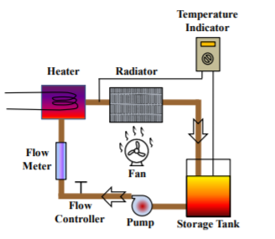

***INITIAL BOUNDARY CONDITIONS***

* *The inlet temperatures of the radiator are: 323k, 327k and 333k.*
* *Fluids used in the radiator are: water, (water+ TiO2), (water +Al2O3).*
* *The velocity of fluid in the radiator is supposed to be 2.2m/s.*
* **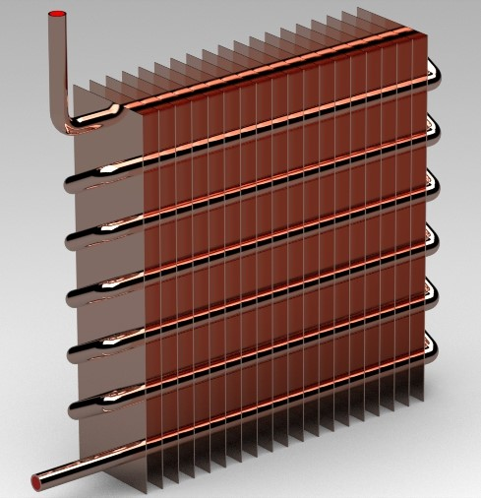***The radiator is designed in the SolidWorks software version 2017. Here, number of fins and tubes are modeled including fluid body and assemble in the software. To design this radiator we used extrude, pattern and revolve options. The dimensions are in mm.*

***THERMOPHYSICAL PROPERTIES OF NANOPARTICLES***

|  |  |  |  |
| --- | --- | --- | --- |
| **MATERIALS** | **ρ(kg/m3)** | **Cp(J/kg-K)** | **K(w/m-k)** |
| ALUMINA(Al2O3) | 3970 | 765 | 40 |
| TITANIA(TiO2) | 4250 | 686.2 | 8.95999 |

*The properties of the binary mixtures (TiO2 + Water) and (Al2O3 + Water) are calculated by the following relationships:*

* *Density of the mixture is calculated by -*
* Specific heat at constant pressure (Cp) is calculated by –
* 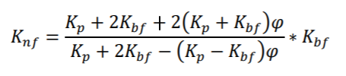Thermal Conductivity (k) of the mixture is calculated by –
* 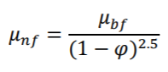*Dynamic viscosity of the mixture is calculated by –*
* *According to Newton's cooling law, the heat transfer rate can be measured by –*

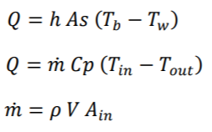

*Based on above relationships the values of various binary mixtures come out to be:*

***PROPERTIES CALCULATED BY USING THE ABOVE RELATIONS AT 0.5 % VOLUMETRIC CONCENTRATION******–***

|  |  |  |  |  |  |
| --- | --- | --- | --- | --- | --- |
| **Nano-Fluid** | **INLET**  **TEMPERATURE**  **(C)** | ˹**˹ρ**  **(kg/m3)** | **Cp**  **(J/kg-K)** | **K**  **(W/m-k)** | **µ**  **(kg-m/s)** |
| **TiO2 + H2O** | 50  54  60 | 1003.9  1002.5  999.5 | 4162.5  4162.5  4167.5 | 0.6492  0.6466  0.6597 | 0.000584  0.000518  0.000471 |
| **Al2O3+ H2O** | 50  54  60 | 1002.9  1001.1  998.1 | 4162.5  4162.5  4167.5 | 0.65  0.6534  0.6603 | 0.000584  0.000518  0.000471 |

***RESULT AND DISCUSSION***

*It is necessary to conduct experiments on the same base fluid (pure water) and verify that the receiver operates under the same operating conditions of temperature and flow rate before beginning work on nanofluids in the radiator.*

***ANSYS ANALYSIS***

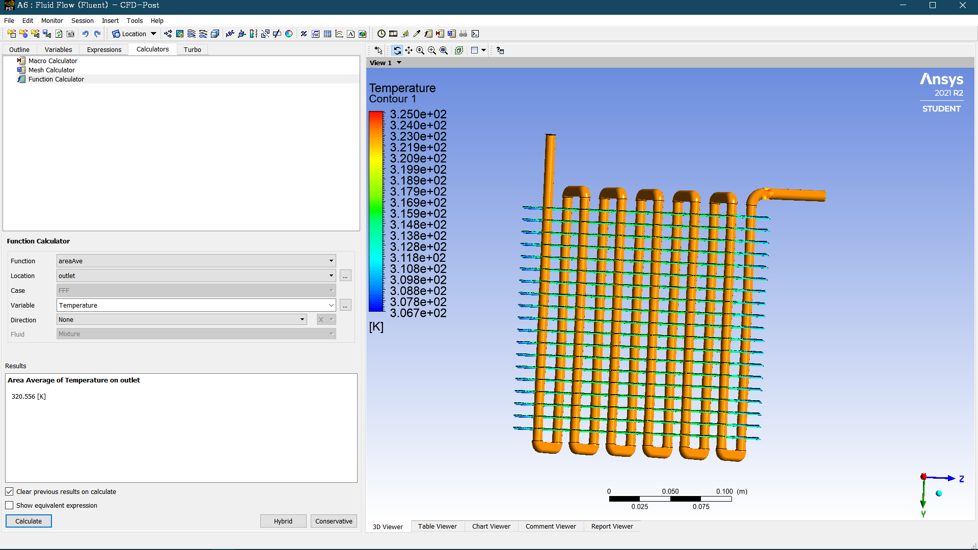*At inlet temperature Tin=323K,*

***H2O Temperature Profile***

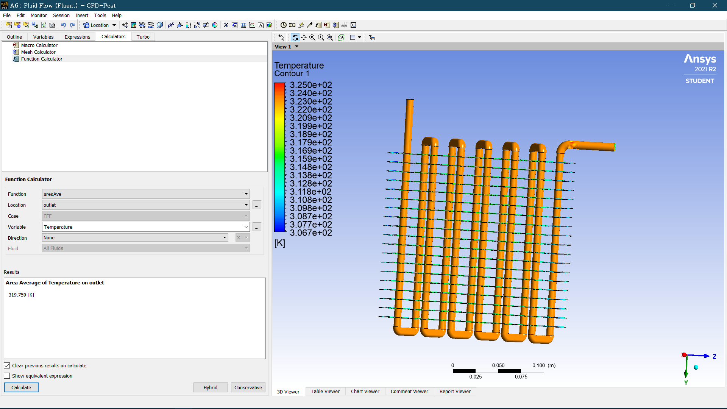

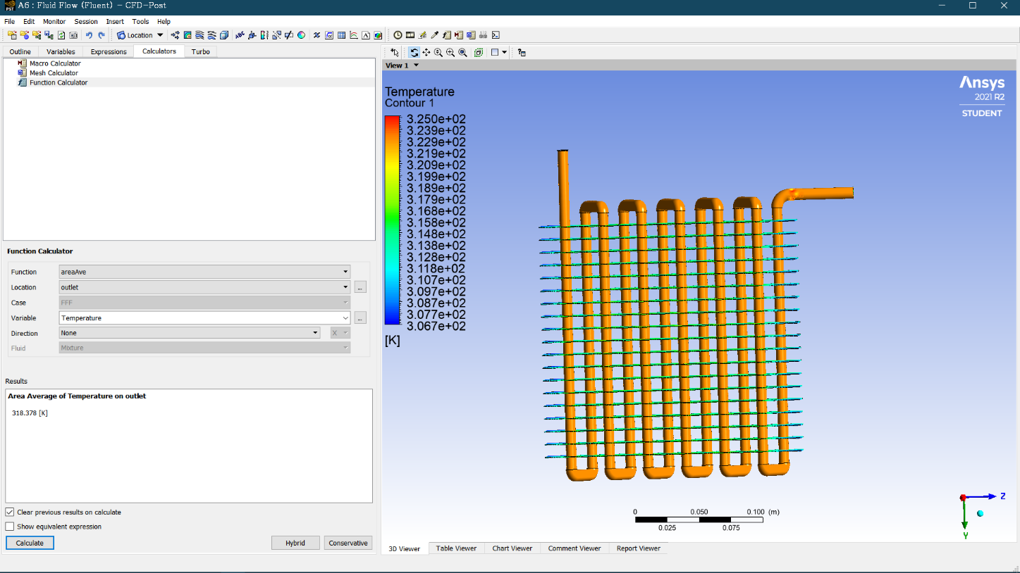***Al2O3 + H2O Temperature Profile***

***TiO2 + H2O Temperature Profile***

***HEAT TRANSFER CALULATION BY USING THE OBSERVATIONS OBTAINED BY ANSYSIS ANALYSIS***

|  |  |  |  |  |  |  |
| --- | --- | --- | --- | --- | --- | --- |
| ***Fluid*** | ***Tinlet***  ***(K)*** | ***Toutlet***  ***(K)*** | ***Tin-Tout***  ***(K)*** | ***ṁ***  ***(kg/s)*** | ***Cp***  ***(J/kg-K)*** | ***HEAT TRANSFER***  ***(Q)***  ***(W)*** |
| **TiO2 + H2O** | *323*  *327*  *333* | 319.74  323.396  325.871 | 3.26  3.604  7.129 | 0.138866  0.138518  0.137995 | 4162.5  4162.5  4167.5 | 1884.377  2077.993  4099.846 |
| **Al2O3+ H2O** | *323*  *327*  *333* | 319.759  323.245  326.065 | 3.241  3.755  6.935 | 0.134690  0.138200  0.137802 | 4162.9  4162.9  4167.9 | 1817.243  2160.312  3983.082 |
| **H2O** | 323  327  333 | 320.556  324.719  327.054 | 2.444  2.281  5.946 | 0.136410  0.136153  0.135740 | 4180  4180  4185 | 1393.451  1298.162  3377.756 |

*After the completion of the simulation in Ansys 2021 noted above and the results of all the inlet temperatures and drawn the graphs as shown below.*

*It is observed from above graph different fluids are used in the radiator and noted the results. From the results, we can say H2O+Al2O3 has a high change in thermal conductivity. When we compared base fluid like water, the H2O + Al2O3 and H2O + TiO2 has 2.95 % and 2.7 % increment in thermal conductivity at 60C and 1% volumetric concentration respectively.*

*We observed from above graph different fluids are used in the radiator and noted the results. From the results, we can say H2O + Al2O3 has a high change in heat transfer rate. When we compared base fluid like water, the H2O + Al2O3 has 39.91% increment in heat transfer rate. Remaining fluid H2O +TiO2 has 37.53% increment in heat transfer rate were observed.*

*It is observed from above graph different fluids are used in the radiator and noted the results. From the results, we can say H2O+TiO2 has a high change in temperature. When we compared base fluid like water, the H2O + TiO2 has 19.9% increment in change in temperature. Remaining fluid H2O +Al2O3 has 16.94% increment in change in temperature were observed.*

***CONCLUSION***

*Different types of nanofluids (Al2O3 and TiO2) are employed to determine the heat transfer rate and compared to the base fluid in this study.*

*According to the simulation analysis, using Al2O3 nanofluid in the radiator results in a 39.91 percent increase in heat transfer rate when compared to using water, while H2O +TiO2 has a heat transfer rate of 37.53 percent at 0.5% volume concentration and 54C inlet temperature. Also, for the same nanofluid, Devireddy Sandhya, studied that the performance of water based TiO2 nano fluids as an automobile radiator coolant is determined experimentally that at the concentration of 0.5% enhancement in heat transfer rate is up to 37% with respect to base fluid.*

***REFERENCES***

1. [*https://www.sciencedirect.com/science/article/pii/S2214157X21003555*](https://www.sciencedirect.com/science/article/pii/S2214157X21003555)
2. [*https://aip.scitation.org/doi/pdf/10.1063/1.5138764*](https://aip.scitation.org/doi/pdf/10.1063/1.5138764)
3. [*https://www.researchgate.net/publication/353847848_The_Heat_Transfer_Performance_of_MWCNT_CuO_and_Al_2_O_3_Nanofluids_in_an_Automotive_Engine_Radiator*](https://www.researchgate.net/publication/353847848_The_Heat_Transfer_Performance_of_MWCNT_CuO_and_Al_2_O_3_Nanofluids_in_an_Automotive_Engine_Radiator)
4. [*http://ijariie.com/AdminUploadPdf/Heat_Transfer_Enhancement_by_Using_Nano_Fluid_ijariie9279.pdf*](http://ijariie.com/AdminUploadPdf/Heat_Transfer_Enhancement_by_Using_Nano_Fluid_ijariie9279.pdf)
5. [*http://www.ieomsociety.org/ieom2019/papers/138.pdf*](http://www.ieomsociety.org/ieom2019/papers/138.pdf)
6. [*http://www.ijettjournal.org/2018/volume-55/number-2/IJETT-V55P214.pdf*](http://www.ijettjournal.org/2018/volume-55/number-2/IJETT-V55P214.pdf)
7. [*https://www.ijsdr.org/papers/IJSDR1705013.pdf*](https://www.ijsdr.org/papers/IJSDR1705013.pdf)
8. [*https://www.irjet.net/archives/V7/i6/ICRTST-2020/IRJET-V7I644.pdf*](https://www.irjet.net/archives/V7/i6/ICRTST-2020/IRJET-V7I644.pdf)
9. [*https://www.jocpr.com/articles/heat-transfer-enhancement-of-thermic-fluid-by-using-nanofluids-in-radiator.pdf*](https://www.jocpr.com/articles/heat-transfer-enhancement-of-thermic-fluid-by-using-nanofluids-in-radiator.pdf)

*10.*[*https://www.ijrte.org/wp-content/uploads/papers/v8i1/A2174058119.pdf*](https://www.ijrte.org/wp-content/uploads/papers/v8i1/A2174058119.pdf)

*11.* [*https://www.ijset.in/wp-content/uploads/IJSET_V7_issue6_159.pdf*](https://www.ijset.in/wp-content/uploads/IJSET_V7_issue6_159.pdf)

*12.*[*https://ijritcc.org/download/conferences/ICIIIME_2017/ICIIIME_2017_Track/1498291760_24-06-2017.pdf*](https://ijritcc.org/download/conferences/ICIIIME_2017/ICIIIME_2017_Track/1498291760_24-06-2017.pdf)

*13.*[*https://www.jchps.com/specialissues/Special%20issue%206/JCHPS%2066%20RAMESHKUMAR%20282-287.pdf*](https://www.jchps.com/specialissues/Special%20issue%206/JCHPS%2066%20RAMESHKUMAR%20282-287.pdf)

*14.* [*https://www.sciencedirect.com/science/article/abs/pii/S073519331630255X?via%3Dihub*](https://www.sciencedirect.com/science/article/abs/pii/S073519331630255X?via%3Dihub)

15.[*https://www.researchgate.net/publication/248088966_Experimental_Study_of_Heat_Transfer_of_a_Car_Radiator_with_CuOEthylene_Glycol-Water_as_a_Coolant*](https://www.researchgate.net/publication/248088966_Experimental_Study_of_Heat_Transfer_of_a_Car_Radiator_with_CuOEthylene_Glycol-Water_as_a_Coolant)